# **USING ANSIBLE TO DEPLOY SAMPLE NGINX/PYTHON APPLICATION INTO KUBERNETES CLUSTER**

## Build docker image for sample nginx/python and push to AWS elastic container registry(ECR) using docker cli.

* Created a docker file in the virtual-box Ubuntu, and written a nginx latest version to pull the nginx image and set expose to port 80.
* Built a docker file using docker build command to create docker image, also set image name and tag.
* Simultaneously created ECR repository and inside that we select image push command.
* Creating IAM with administrative access permission and also creating access key for AWS configuration.
* Pushed the image to ECR by following the view push commands in the ECR after finishing the AWS configuration.

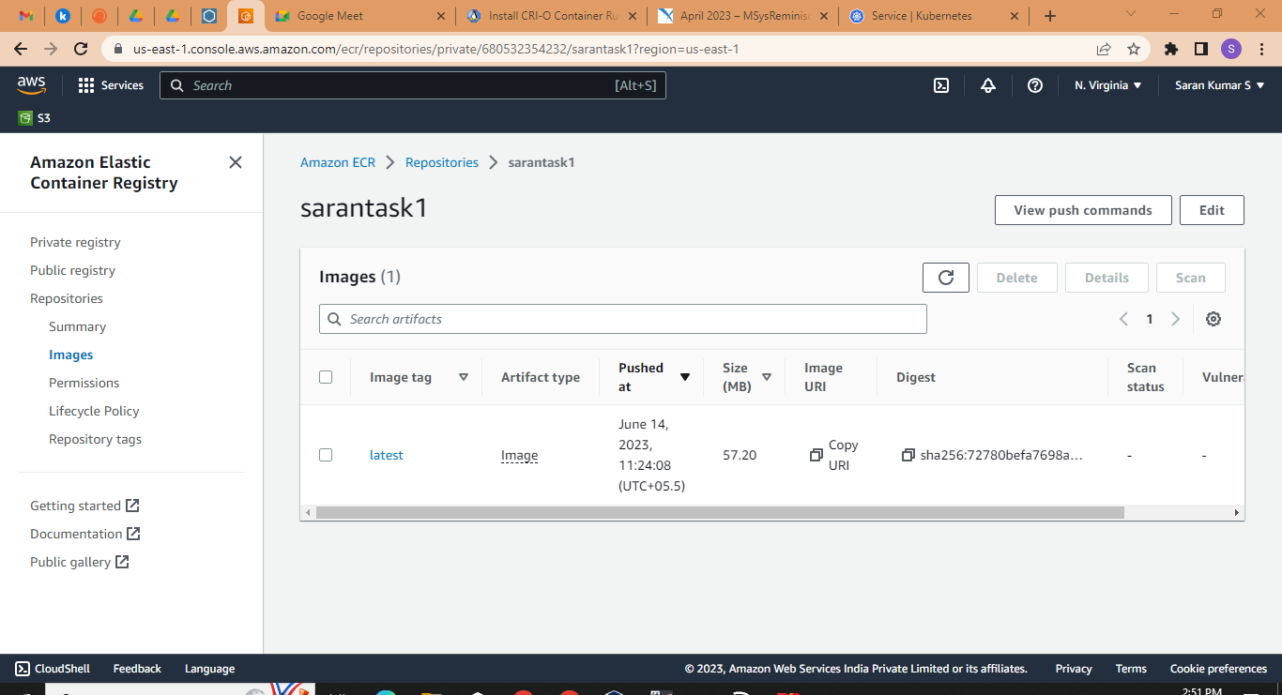

## Create ansible role to deploy nginx application into kubernetes cluster.

* Created inventory inside the etc/ansible/hosts.
* Created ansible role inside the etc/ansible/roles using “ansible-galaxy init <rolename>”and inside the tasks.
* Created a yml file with three tasks such as pulling image from ECR, deployment.yml, service.yml.
* Running the minikube and setting based on our application
* Running the playbook using ansible-playbook <playbook name.yml> command.
* Checking the playbook health using kubectl gets pods commands.
* Checking the deployment health and service health using <kubectl get deployment> and <kubectl get svc>
* Checking all the yaml file health <kubectl get all>

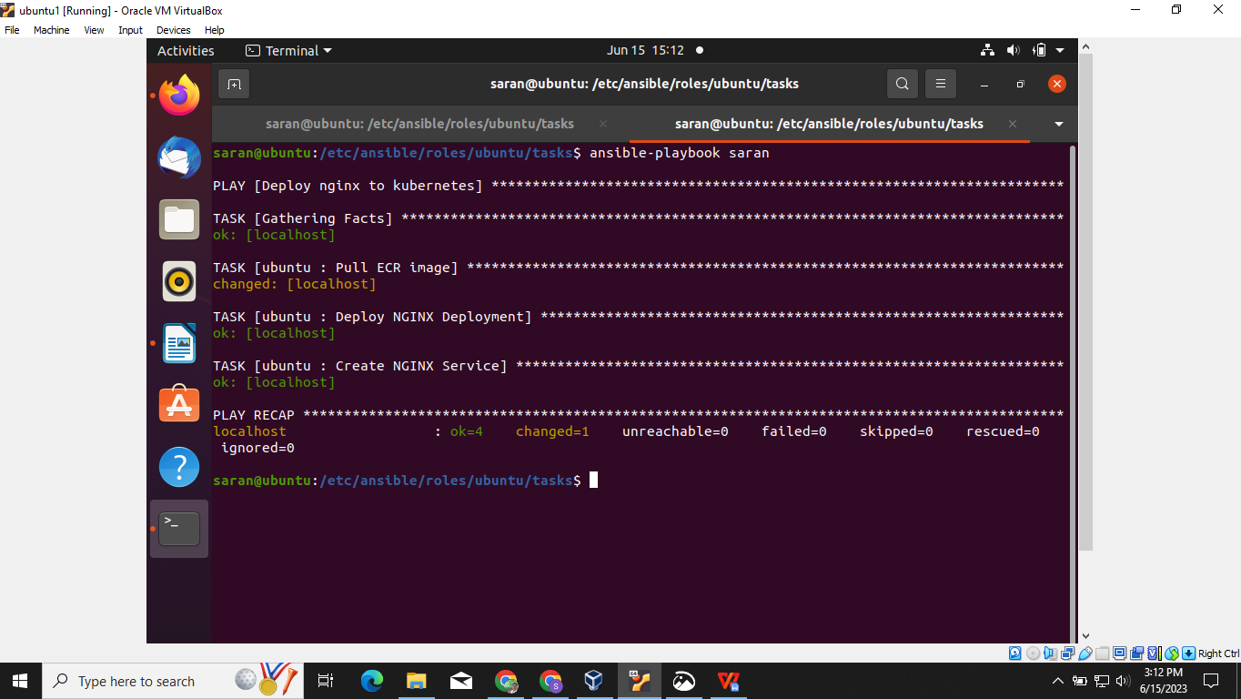

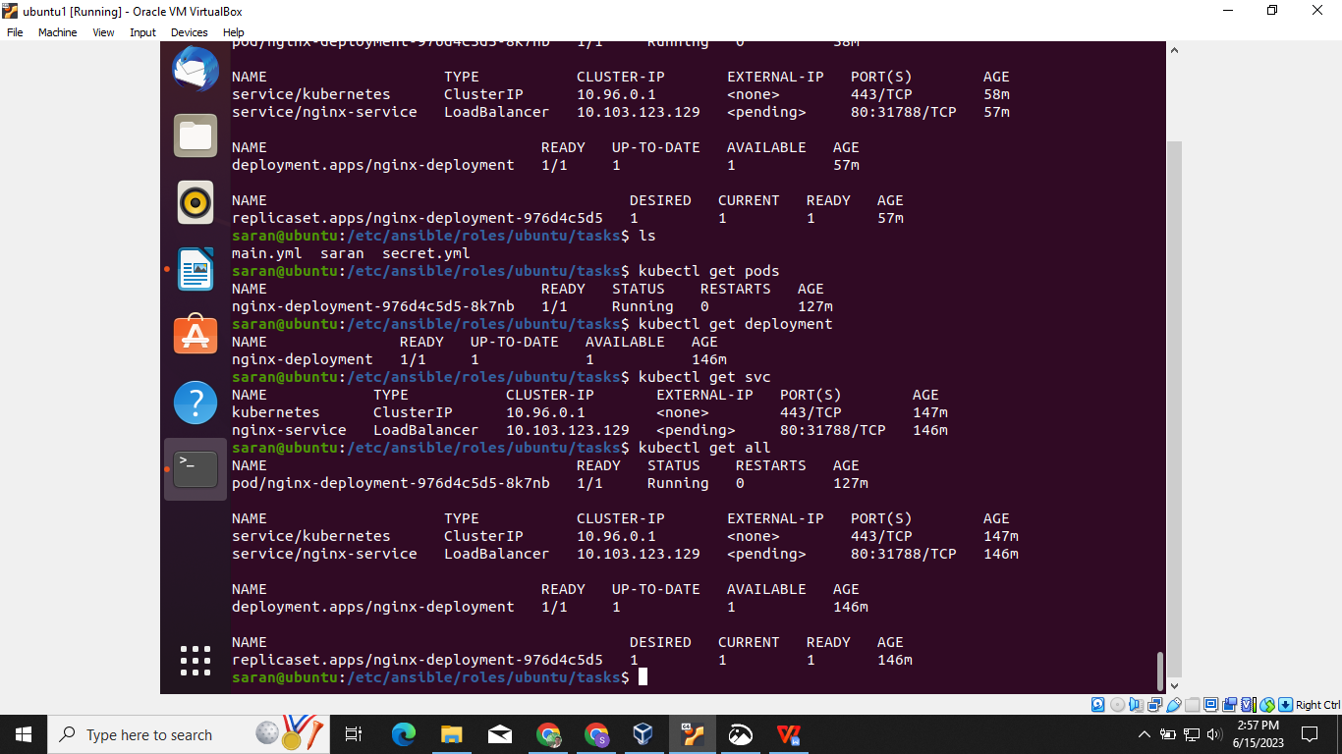

* Container image should be pulled from aws elastic container registry(ECR).

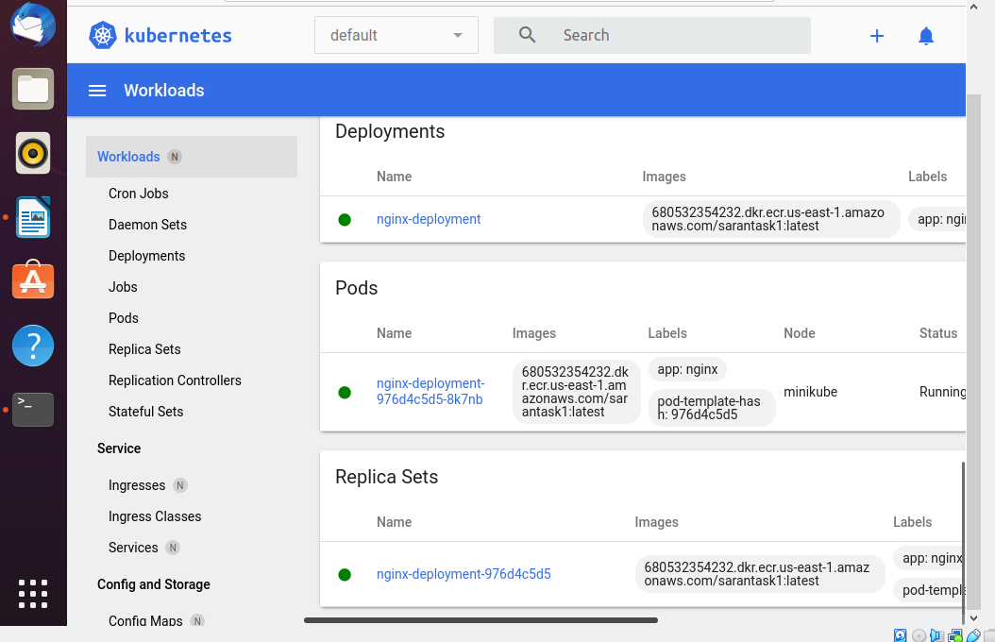

## Outcome is application deployed and run in k8s cluster. Able to access nginx website with url. <http://<ip_address>:<port>.>

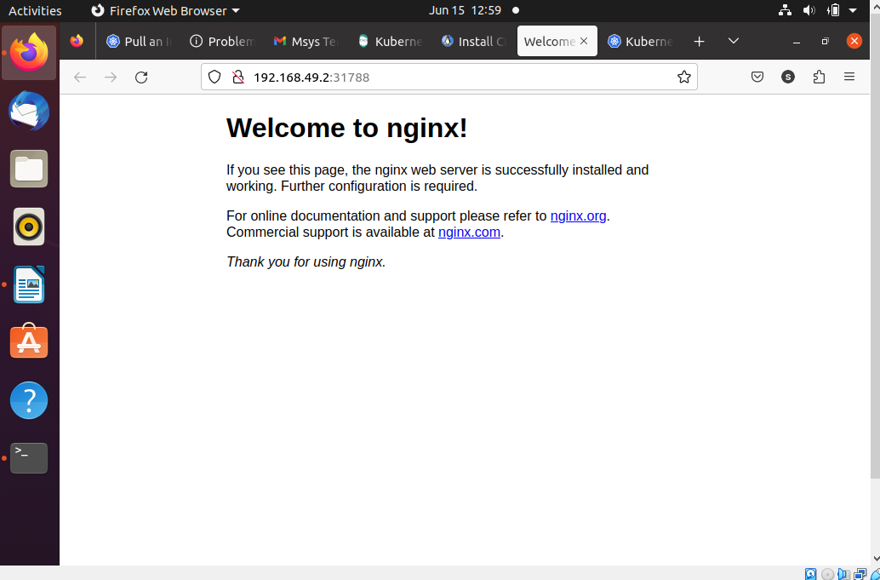

## Keep the code stuff into git repository.

[https://github.com/Sarankumar2424/Ansiblek8sdeployment.git](https://github.com/Sarankumar2424/Ansiblek8sdeployment.git" \t "https://chat.google.com/u/0/_blank)